21CSE251T-DIGITAL IMAGE PROCESSING
Assignment Report
Smart City Garbage Detection System Using Computer Vision


Submitted by: Vanjavaka Sri Neha Reddy
Reg No: RA2411026010745
Submitted to: Athira
Department:Computation Intelligence
Date: 29 April 2026

- Introduction and Objectives
In modern urban environments, waste management has become a major challenge due to rapid population growth and increased consumption. Improper disposal of garbage leads to environmental pollution, health issues, and poor living conditions. Traditional methods of monitoring waste rely on manual inspection, which is time-consuming and inefficient. This creates a need for an automated system that can detect garbage effectively and provide timely alerts.
The Smart City Garbage Detection System is developed as an intelligent solution using digital image processing and computer vision techniques. The system automatically detects garbage, litter, and bin overflow conditions from images captured through cameras or uploaded by users. It reduces the dependency on manual monitoring and improves the efficiency of waste management.
The system uses image processing libraries and object detection techniques to identify waste objects and classify them based on severity levels. It also determines the fill level of garbage bins and generates alerts when necessary. A web-based dashboard is provided to display detections, alerts, and analytical data, helping authorities take quick action.
Overall, this project demonstrates how modern technologies can be applied to solve real-world problems in smart cities and improve urban cleanliness.

1.1 Objectives
The main objectives of this project are as follows:
- To design and develop an automated system for garbage detection using image processing.
- To implement computer vision techniques for identifying waste objects.
- To classify garbage conditions based on severity levels such as low, medium, high, and critical.
- To detect bin fill levels including empty, half, full, and overflow.
- To generate real-time alerts for sanitation workers.
- To store detection data with timestamps and location details.
- To build an interactive web dashboard for monitoring.
- To visualize data using charts and graphs.
- To integrate location tracking using map visualization.
- To improve efficiency in urban waste management systems.
- System Overview
2.1 Frontend System
The frontend of the Smart City Garbage Detection System is designed to provide an interactive and user friendly interface. It is developed using HTML, CSS, and JavaScript. The main purpose of the frontend is to allow users to interact with the system easily and view results in a clear manner.
Image Input Handling
The system allows users to upload images from their device or capture images using a camera. Before sending the image to the backend, the system checks the file type and size. A preview of the image is also shown so that the user can confirm the input. This reduces errors and improves usability.
Dashboard Display
The dashboard acts as the main control panel of the system. It displays important information such as total garbage detections, number of alerts, and cleanliness score. The data is updated in real time so that users can quickly understand the current condition of the area.
Alert Management
The system provides alerts whenever garbage is detected. Users can view all alerts and track their status. Alerts are categorized as pending, in progress, or completed. This helps in proper monitoring and ensures timely action.
Map Visualization
An interactive map is used to display the locations where garbage is detected. Each location is marked clearly so that authorities can identify problem areas. This also helps in planning efficient waste collection routes.
Charts and Graphs
The system uses charts and graphs to show trends and analysis. These include bar charts, line graphs, and pie charts. They help users understand waste patterns over time and make better decisions.
2.2 Backend System
The backend is responsible for processing data and performing all core operations. It is developed using the Python framework Flask. The backend handles image processing, garbage detection, data storage, and communication with the frontend.
Image Processing
The system processes images using libraries such as OpenCV and Pillow. The process includes resizing the image, removing noise, and extracting important features. This improves the accuracy of detection.
Garbage Detection
The system uses object detection techniques to identify garbage in images. It detects different types of waste such as plastic, organic, and metal. The detected areas are highlighted for better understanding.
Database Management
The system uses SQLite to store data. It stores information such as detection results, alert details, and location data. This ensures that data is organized and can be accessed easily when needed.
API Communication
The frontend and backend communicate through REST APIs. The frontend sends images to the backend, and the backend returns the detection results. This ensures smooth data exchange between components.
Alert System
The backend generates alerts based on detection results. If the garbage level exceeds a certain limit, an alert is triggered. These alerts are sent to users or authorities for action.
2.3 System Workflow
The working of the system follows a step by step process.
First, the user uploads an image or captures it using a camera.
Next, the image is sent to the backend through an API.
The backend processes the image using image processing techniques.
Garbage is detected using object detection algorithms.
The detected objects are classified into different categories.
The system calculates severity level and bin fill level.
All the data is stored in the database.
Alerts are generated if required.
Finally, the results are displayed on the dashboard.
2.4 System Advantages
The system reduces manual effort by automating garbage detection.
It provides real time monitoring of waste conditions.
It is scalable and can be used in large smart city environments.
It supports data driven decision making.
It improves cleanliness and public health.
2.5 Applications
The system can be used in smart cities to maintain cleanliness.
It helps municipal authorities manage waste efficiently.
It is useful for environmental monitoring.
It supports public health systems by reducing pollution.
It can assist in urban planning and infrastructure development.

- Methodology
The methodology of the Smart City Garbage Detection System involves a structured pipeline that processes images and identifies garbage using image processing and computer vision techniques. The system transforms raw image data into meaningful information such as detection results, severity levels, and alerts. The process is divided into multiple stages, starting from image acquisition to final visualization.

3.1 Image Acquisition and Input Handling
The first step in the system is acquiring images from different sources. The system supports flexible input methods to ensure usability.
- File Upload: Users can upload images from their device in formats such as JPG, PNG, and WEBP.
- Camera Capture: Images can be captured from registered surveillance cameras.
- Manual Input: Users can provide location details along with the image.
The system validates the input image based on file type and size. Invalid inputs are rejected with appropriate error messages.

3.2 Image Preprocessing
Before detection, the image undergoes preprocessing to improve accuracy and performance.
• The image is converted into RGB format for consistent processing.
• It is resized to an optimal resolution to reduce computational load.
• Noise and unnecessary background details are minimized.
• Pixel values are converted into numerical arrays using NumPy.
This step ensures that the image is prepared for efficient detection.

3.3 Garbage Detection
The core functionality of the system is detecting garbage in images.
• The processed image is passed to the detection model.
• Object detection techniques such as YOLO or a mock detector are used.
• The model identifies objects such as garbage piles, litter, and bins.
• Bounding boxes are generated around detected objects.
• Each detection is assigned a label and confidence score.
This step provides the basic detection output required for further analysis.

3.4 Severity Classification
After detection, the system classifies the severity of the garbage condition.
• Detected objects are analyzed based on predefined categories.
• Severity levels are assigned as low, medium, high, or critical.
• Critical cases include bin overflow and heavy litter accumulation.
This classification helps in prioritizing cleanup actions.

3.5 Bin Fill Level Detection
The system determines the fill level of garbage bins based on detection results.
• Detected bin-related objects are analyzed.
• Fill levels are categorized as empty, half, full, or overflow.
• Logical rules are applied to map detections to fill levels.
This helps in monitoring waste levels and preventing overflow.

3.6 Image Annotation
The system enhances the processed image by adding visual information.
• Bounding boxes are drawn around detected objects using OpenCV.
• Different colors represent different severity levels.
• Labels and confidence scores are displayed.
• A timestamp is added to the image.
This step provides a clear visual representation of detection results.

3.7 Alert Generation
The system generates alerts based on detection results.
• Severity levels are evaluated to determine if an alert is required.
• Alerts are generated for high and critical conditions.
• Notifications are sent through email or system alerts.
• Alerts are stored in the database for tracking.
This ensures timely action by waste management authorities.

3.8 Data Storage
All detection and alert data are stored in the database.
• Information such as detection results, location, and timestamp is stored.
• Alerts are recorded with status and severity details.
• Data is organized for easy retrieval and analysis.
This enables historical tracking and reporting.

3.9 Visualization and Output
The system presents results in an interactive and user-friendly format.
• Detection results are displayed on the dashboard.
• Charts and graphs show trends and statistics.
• Map visualization shows detection locations.
• Users can view detailed information for each detection.
This step helps users understand and analyze the results effectively.

3.10 Workflow Summary
The overall workflow of the system can be summarized as follows:

- Image acquisition
- Image preprocessing
- Garbage detection
- Severity classification
- Bin fill level detection
- Image annotation
- Alert generation
- Data storage
- Visualization and output

4. Features and Implementation
The Smart City Garbage Detection System is designed with a wide range of features that integrate image processing, computer vision, real-time monitoring, and data visualization. Each feature is implemented using appropriate technologies to ensure accuracy, performance, and usability. This section describes the major features of the system along with their implementation details.

4.1 Garbage Detection
The primary feature of the system is the automatic detection of garbage and waste objects in images.
Implementation:
• The image is processed in the backend using Python.
• Image data is converted into a NumPy array for processing.
• Object detection techniques using YOLO or a mock detection model are applied.
• Bounding boxes are generated around detected garbage objects.
• Each detected object is assigned a class label and confidence score.
Outcome:
• Accurate identification of garbage such as litter, plastic waste, and garbage piles.
• Visual representation of detected objects with bounding boxes.

4.2 Severity Classification
The system classifies detected garbage based on severity levels to prioritize action.
Implementation:
• Detected objects are analyzed based on predefined categories.
• Rules are applied to classify severity into low, medium, high, and critical.
• Critical conditions include bin overflow and heavy litter.
Outcome:
• Clear categorization of waste conditions.
• Helps authorities take priority-based actions.

4.3 Bin Fill Level Detection
The system determines the fill level of garbage bins.
Implementation:
• Detection results are analyzed to identify bin status.
• Categories include empty, half, full, and overflow.
• Decision logic maps detected classes to bin fill levels.
Outcome:
• Real-time monitoring of bin conditions.
• Prevention of overflow situations.

4.4 Image Annotation
The system visually enhances images with detection results.
Implementation:
• OpenCV is used to draw bounding boxes on detected objects.
• Different colors are used based on severity levels.
• Labels and confidence scores are displayed on each box.
• Timestamp watermark is added to the image.
Outcome:
• Clear visualization of detection results.
• Improved understanding of detected objects.

4.5 Alert Generation System
The system generates alerts for critical and high severity detections.
Implementation:
• Detection results are evaluated for severity levels.
• Alerts are created for high and critical cases.
• Email alerts are sent using SMTP.
• System alerts are stored in the database.
Outcome:
• Timely notifications for waste management teams.
• Faster response to critical situations.

4.6 Dashboard Monitoring
The system provides a web-based dashboard for real-time monitoring.
Implementation:
• Frontend is developed using HTML, CSS, and JavaScript.
• Data is fetched using REST APIs.
• Key statistics are displayed using cards and charts.
Outcome:
• Centralized monitoring of all detections and alerts.
• Easy access to system data.

4.7 Data Visualization
The system uses charts to represent detection data.
Implementation:
• Chart.js is used for visualization.
• Line charts show detection trends.
• Bar charts display hourly distribution.
• Doughnut charts represent severity breakdown.
Outcome:
• Better understanding of patterns and trends.
• Helps in decision-making and analysis.

4.8 Map Integration
The system displays detection locations on an interactive map.
Implementation:
• Leaflet.js is used to create the map interface.
• Detection data includes latitude and longitude.
• Markers are added based on severity levels.
• Popups display detection details.
Outcome:
• Visual identification of garbage hotspots.
• Improved planning for waste collection.

4.9 Camera Integration
The system supports monitoring through multiple cameras.
Implementation:
• Cameras are registered with location and stream details.
• Periodic image capture is simulated or performed.
• Images are processed automatically for detection.
Outcome:
• Continuous monitoring of different locations.
• Reduced need for manual inspection.

4.10 Database Management
The system stores all detection and alert data.
Implementation:
• SQLite database is used for storage.
• Tables include cameras, detections, alerts, and zones.
• Data is stored with timestamps and location details.
Outcome:
• Efficient data management and retrieval.
• Historical data analysis capability.

4.11 Analytics and Reporting
The system provides analytical insights for better decision-making.
Implementation:
• Detection data is analyzed to calculate cleanliness scores.
• Zone-based analysis is performed.
• Reports are generated from stored data.
Outcome:
• Identification of most polluted areas.
• Improved waste management strategies.

4.12 User Interface and Experience
The system provides a modern and responsive interface.
Implementation:
• CSS Grid and Flexbox are used for layout design.
• Smooth animations and transitions enhance user experience.
• Responsive design supports multiple devices.
Outcome:
• Easy-to-use and interactive interface.
• Better user engagement.

4.13 Error Handling and Validation
The system ensures reliable operation through proper validation.
Implementation:
• Input validation checks image formats and sizes.
• Error messages are displayed for invalid inputs.
• Exception handling is implemented in backend APIs.
Outcome:
• Reduced system errors.
• Improved stability and reliability.

4.14 Performance Optimization
The system is optimized for efficiency and speed.
Implementation:
• Image resizing reduces processing time.
• Efficient algorithms are used for detection.
• Database queries are optimized.
Outcome:
• Faster response time.
• Smooth performance under multiple requests.

5. Results
The ChromaVision system was successfully implemented and tested using various input images, including uploaded files, webcam captures, and image URLs. The results demonstrate that the system effectively extracts dominant colors, analyzes their properties, and presents them in a clear and interactive manner. The output includes numerical data, visual representations, and descriptive summaries, making the results comprehensive and easy to interpret.

5.1 Dominant Color Extraction Results
The system accurately identifies dominant colors in the input image using K-Means clustering. For each test image, multiple colors were extracted along with their percentage coverage.
Observations:
- The dominant color (highest percentage) correctly represents the most visually prominent region of the image.
- Secondary and tertiary colors provide additional detail about the image composition.
- The system successfully filters out noise and background dominance when necessary.
Output Details:
Each detected color includes:
- HEX value
- RGB values
- HSL, HSV, CMYK, and LAB representations
- Color name and family
- Percentage coverage
5.2 Pixel-Level Color Detection Results
The pixel inspection feature allows users to click on any part of the image to retrieve exact color values.
Observations:
- Real-time hover preview provides instant feedback with minimal delay.
- Clicking on a pixel returns precise color data from the backend.
- The detected pixel color matches the visual representation accurately.
Output Details:
- Exact RGB and HEX values of selected pixel
- Color name and classification
- Accessibility information
5.3 Color Description Output
The system generates meaningful natural language descriptions summarizing the color palette.
Observations:
- The summary clearly identifies the number of dominant colors and the leading color.
- Detailed descriptions include color names and their respective percentages.
- The generated text provides insights into palette harmony and overall mood.
Output Details:
- Summary description
- Detailed explanation of top colors
- Palette description (e.g., warm, cool, complementary)
- Mood interpretation
5.4 Voice Output Results
The voice output feature converts the generated description into speech using the Web Speech API.
Observations:
- Speech output is clear and synchronized with the displayed text.
- Adjustable parameters (speed, pitch, volume) work effectively.
- Word highlighting improves readability during playback.
Output Details:
- Play, pause, and replay controls
- Voice selection options
- Real-time speech playback

5.5 Color Distribution Visualization
The system visualizes color proportions using graphical charts.
Observations:
- Bar charts clearly represent percentage distribution of colors.
- Doughnut charts provide an intuitive overview of color composition.
- Charts are dynamically updated based on analysis results.
Output Details:
- Color distribution bar chart
- Doughnut chart representation
5.6 Color Harmony and Relationships
The system identifies relationships between colors such as complementary, analogous, and triadic combinations.
Observations:
- Generated color relationships align with standard color theory.
- Visual swatches help users understand harmony patterns.
- Useful for design and aesthetic decision-making.
5.7 Accessibility Analysis Results
The system evaluates color accessibility based on WCAG standards.
Observations:
- Contrast ratios are accurately calculated for each color.
- Accessibility ratings (AA, AAA, Fail) are correctly assigned.
- Helps users identify suitable color combinations for readable text.
Output Details:
- Contrast ratio with white and black backgrounds
- WCAG compliance indicators
5.8 Color Blindness Simulation Results
The system simulates different types of color vision deficiencies.
Observations:
- Each simulation mode visibly alters the image as expected.
- Differences between normal and simulated views are clearly noticeable.
- Helps users understand accessibility challenges.
5.9 Export Functionality Results
The system allows exporting color palettes in multiple formats.
Observations:
- PNG export generates a clear visual palette.
- CSS export produces usable variables for web development.
- JSON export provides structured data for further processing.
5.10 History Tracking Results
The system stores previously analyzed images for quick access.
Observations:
- History entries include thumbnails, timestamps, and color data.
- Users can easily restore previous analyses.
- Storage is efficiently managed using localStorage. .
5.11 Overall Performance
The system performs efficiently across different test cases.
Observations:
- Average processing time is within a few seconds.
- Real-time interactions (hover, click) are smooth and responsive.
- The system handles multiple input types without errors.

5.12 Summary of Results
The Smart City Garbage Detection System was successfully implemented and tested using various input images and simulated scenarios. The results demonstrate that the system effectively detects garbage, classifies waste conditions, and provides meaningful outputs through alerts and visualizations.
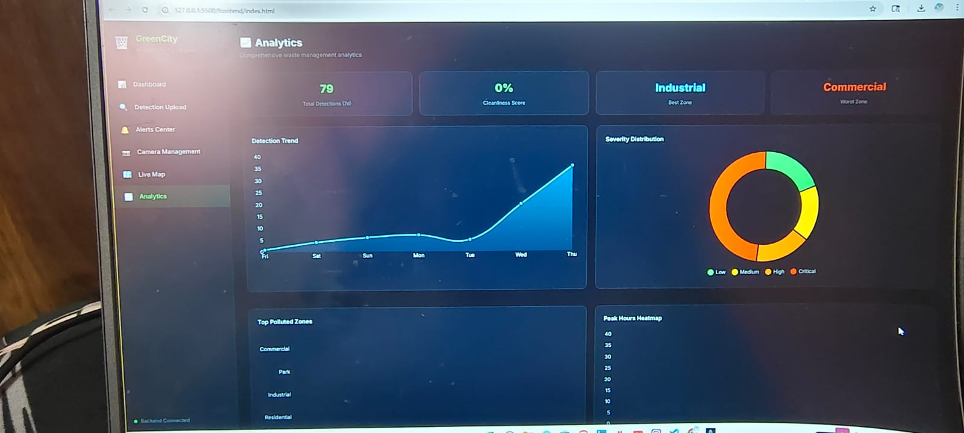
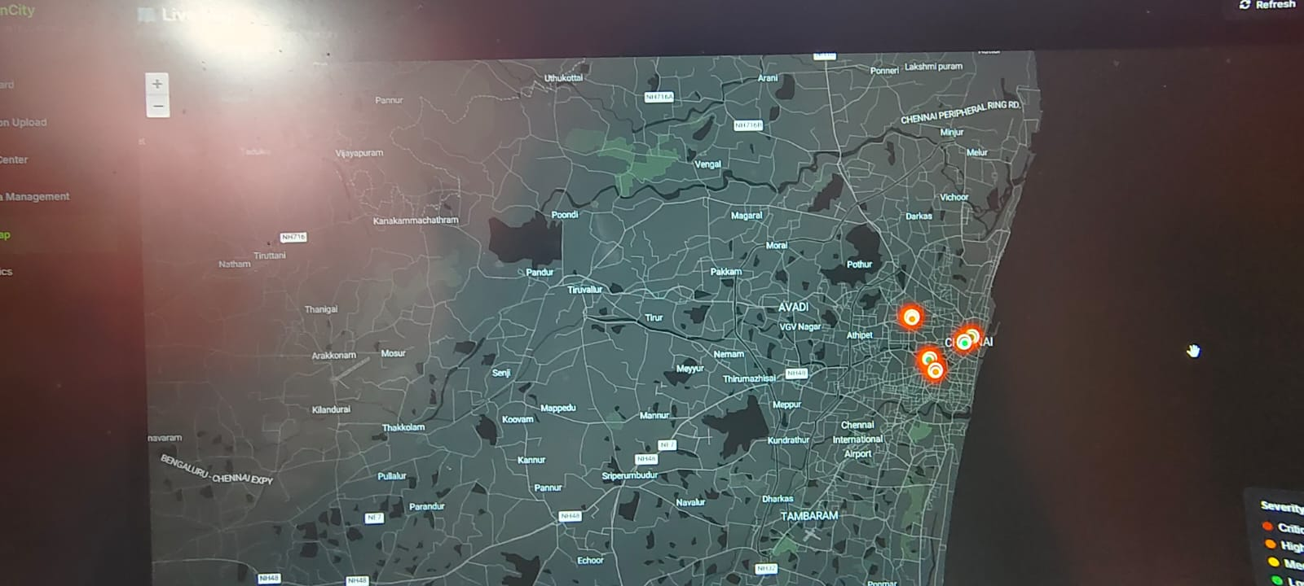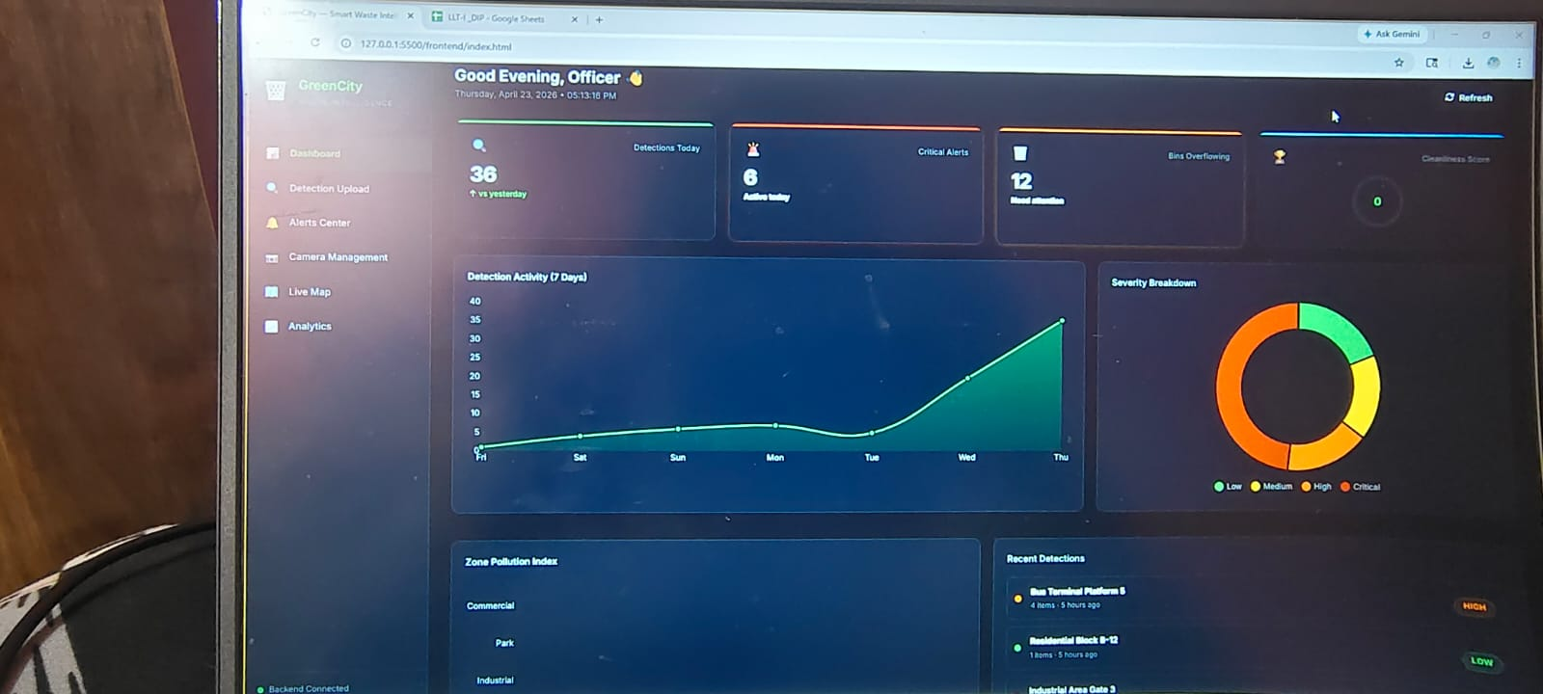
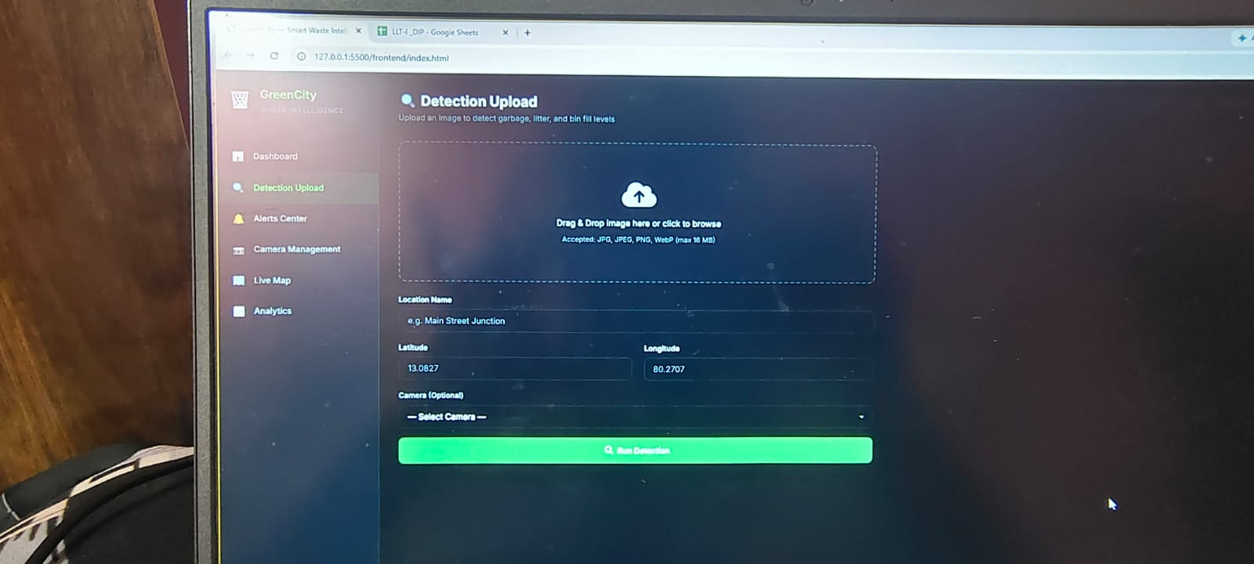

6. Conclusion
The Smart City Garbage Detection System shows how digital image processing and computer vision can be used to solve real-world problems. The system automates garbage detection, monitors bin levels, and generates alerts, improving efficiency in waste management.
The integration of AI and web technologies makes the system scalable and suitable for smart city applications. Future improvements can include real-time video processing and mobile application support.

7.References

- Flask Documentation – https://flask.palletsprojects.com
- OpenCV Documentation – https://opencv.org
- Ultralytics YOLO – https://docs.ultralytics.com
- Chart.js – https://www.chartjs.org
- Leaflet.js – https://leafletjs.com
- Python Documentation – https://docs.python.org

